|  |  |
| --- | --- |
| Picture1 | ***DEPARTMENT OF INFORMATION TECHNOLOGY***  ***KNOWLEDGE MAP***  ***Choice Based Credit and Grading System (REVISED 2016)*** |

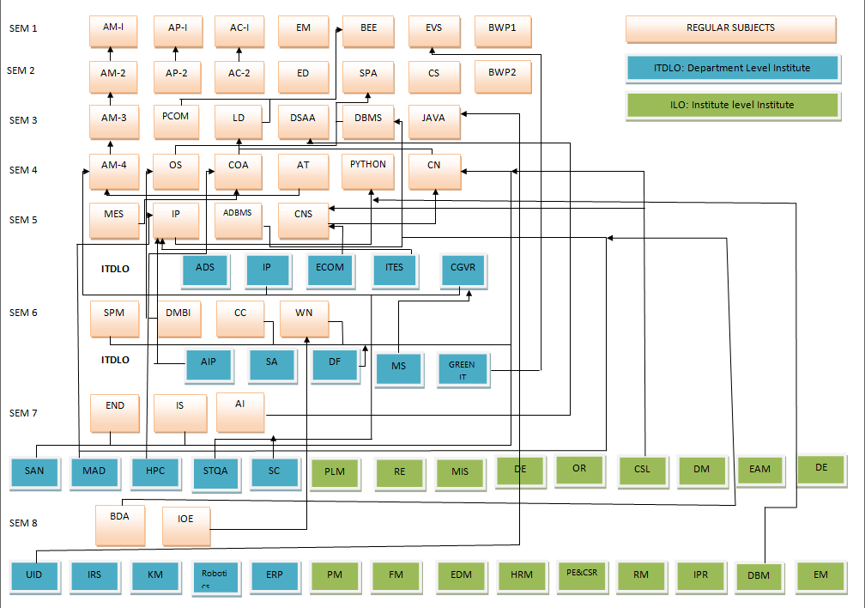

**Semester 5:**

MEP [ITC501]: Microcontroller and Embedded Programming

IP [ITC502]: Internet programming

ADMT [ITC503]: advanced data management technology

CNS [ITC504]: Cryptography & Network Security

**ADS [ITDLO5011]: Advanced Data Structures & Analysis of Algorithms**

**IP [ITDLO5012]: Image Processing**

**ECOM [ITDLO5013]: E-Commerce & E-Business**

**ITES [ITDLO5014]:IT Enabled Services**

**CGVR [ITDLO5015]: Computer Graphics & Virtual Reality**

**Semester 4:**

AM-IV [ITC401]: Applied Mathematics-4

CN [ITC402]: computer networks

OS [ITC403]: operating systems

COA [ITC404]: Computer organization & Architecture

AT [ITC405]: Automata Theory

**Semester 3 :**

AM-III [ITC301]: Applied Mathematics-3

LD [ITC302]: Logic design

DSAA [ITC303]: Data Structure & Analysis

DBMS [ITC304]: Database management systems

PCOM [ITC305]: Principles of communication

**Semester 7:**

END [ITC701]: Enterprise network design

IS [ITC702]: infrastructure security

AI [ITC703]: Artificial intelligence

**SAN [ITDLO7031]: Storage Area Networks**

**MAD [ITDLO7032]: Mobile Application**

**Development**

**HPC [ITDLO7033]: High Performance**

**Computing**

**STQA [ITDLO7034]: Software Testing and Quality Assurance**

**SC [ITDLO7035]: Soft Computing**

**PLM [ILO7011]:Product Lifecycle Management**

**RE [ILO7012]: Reliability Engineering**

**MIS [ILO7013]: Management Information System**

**DE [ILO7014]: Design of Experiments**

**OR [ILO7015]: Operation Research**

**CSL [ILO7016]: Cyber Security and Laws**

**DM [ILO7017]: Disaster Management and**

**Mitigation Measures**

**EAM [ILO7018]: Energy Audit and Management**

**DE [ILO7019]: Development Engineering**

**Semester 6:**

SPM [ITC601]: Software Engineering with Project Management

DMBI [ITC602]: Data Mining and Business Intelligence.

CC [ITC603]: Cloud Computing &

Services

WN [ITC304]: Wireless Networks

**AIP [ITDLO6021]:Advance Internet Programming**

**SA [ITDLO6022]: Software Architecture**

**DF [ITDLO6023]: Digital Forensics**

**MS [ITDLO 6024]: Multimedia Systems**

**GIT [ITDLO6025]: Green IT**

**Semester 8:**

BDA [ITC801]: Big data analysis

IOE [ITC802]: Internet of everything

**UID [ITDLO8041]: User Interaction Design**

**IRS [ITDLO8042]: Information Retrieval Systems**

**KM [ITDLO8043]: Knowledge Management**

**ITDLO8044: Robotics**

**ERP [ITDLO8045]: Enterprise Resource Planning**

**PM [ILO8021]: Project Management**

**FM [IO8022]: Finance Management**

**EDM [ILO8023]: Entrepreneurship Development and Management**

**HRM [ILO8024]: Human Resource Management**

**PE&CSR [ILO8025]: Professional Ethics and CSR**

**RM [ILO8026]: Research Methodology**

**IPR [ILO8027]: IPR and Patenting**

**DBM [ILO8028]: Digital Business Management**

**EM [ILO8029]: Environmental Management**